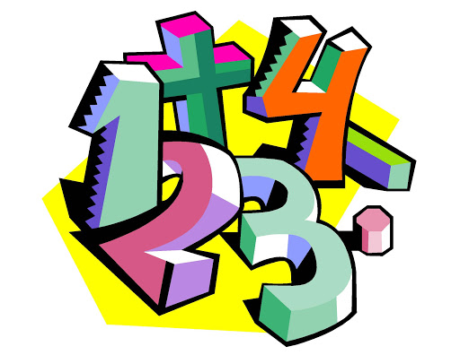

Arithmetic- week commencing 30th March 2020.
Quick recall questions:
- 2/3 x 4/5 =
- 3.4 + 2.567=
- 67 x 504 =
- 0.3 x 40=
- 60 ÷ 2 + ( 4 x 3) =
Times tables practice! (8 times table):
7 x 8 =
2 x 8 =
60 x 8 =
8 squared?
5 x 8 =
9 x 8 =
6 x 8 =
3 x 8 =
4 x 8 =
11 x 8 =

Percentages of a number:
- 34%of 2400=
- 99% of 1000=
- 75% of 2000=
- 42% of 3200=
- 50% of 320=
- 72% of 1200=

