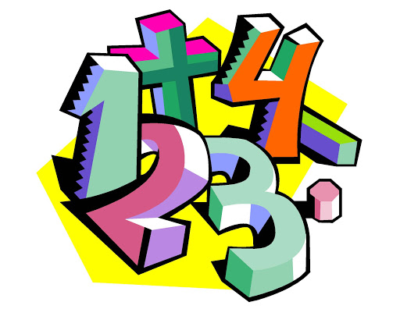

Arithmetic- week commencing 30th March 2020.
Quick recall questions:
- 34.89 x _________ = 348.9
- 45.982 x 100=
- 72 ÷ (11-3) =
- 824 x 17 =
- 9/10 + 1/4=
Times tables practice! (8 times table):
7 x 8 =
4 x 8 =
60 x 8 =
8 squared?
9 x 8 =
3 x 8 =
6 x 8 =
3 x 8 =
5 x 8 =
11 x 8 =

Percentages of a number:
- 40% of 3000=
- 12% of 1800=
- 50% of 420=
- 25% of 480=
- 75% of 1000=
- 12% of 1400=
- 95% of 8200=

