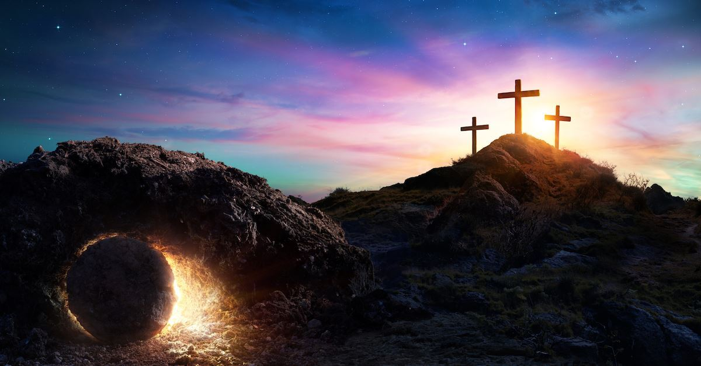

The Easter Story- the resurrection of Jesus.
For today and tomorrow’s session, you are going to be detectives of the Jerusalem Police Department, trying to solve the mystery of the missing body, which was in the tomb!
You will investigate a number of pieces of evidence: statements from the witnesses, evidence from the crucifixion and additional evidence from the bible.
Recap: Jesus was seen dying on the cross on Friday but according to the followers of Jesus, by Sunday morning, the body was no longer there.
First task: What could the explanations be for the body going missing?
Write a list of these and then rate these out of 10 (1 = least believable, 10 = most believable).
Think about which evidence which would be needed to prove each one of your explanations. Write down which one you believe and why.

(See task 2 below)
Task 2: Time to reflect on the evidence!
Look at the following evidence- does it support any of your explanations? Why? Why not?
The Roman Guard.
Pilate, the Roman governor, ordered that the tomb be made secure as possible. The official Roman seal was placed upon the closed tomb after the body was put inside. This warned grave robbers of serious penalties for breaking it. 16 guards were keeping watch outside the tomb and in the surrounding area.

The body is still missing!
All parties- Roman and Jewish – were in agreement that the tomb was empty on Sunday. Only the empty grave cloths that Jesus had been wrapped in were in the cave. The body has not been found.
The stone was really heavy!
Jesus was placed in a tomb/ cave converting the entrance to keep the body safe from the robbers. The stone would have taken multiple people to move it and a long time to move it.

Tomorrow, we will consider the witness statements!

