BOMBS WILL NOT BEAT BRITAIN

Giles Hardy, War Correspondent

Last night, the Luftwaffe launched an unprecedented assault on London. At 11pm, as the air raid sirens echoed across the city, the first explosions occurred. It is estimated that the German bombers have claimed over 1000 lives and destroyed more than 11,000 houses.

At 30 minutes past midnight, the storm broke over London: eye witnesses reported that a cloud of German bombers filled the sky dropping incendiary bombs like rain. They hit the ground with their curious and distinctive plop-plop sound and then erupted in a sizzle of bluish-white flame. Bombs fell for most of the night, as the enemy planes were bravely fought off by the RAF. Although much of London was badly hit, it was the East End that suffered the most damage. Bethnal Green was pulverised by the bombs with over 100 people killed by the explosions.

At 15 Mann Street, Southwark, a couple explained that as they were sitting either side of their kitchen table, an explosion dislodged their chimney. It fell noiselessly, shattering the table but leaving the pair without a scratch. Daniel Johnson, who spent most of the night in an Anderson Shelter, told us “When I returned to my bedroom the windows were smashed and my bed was covered in large shards of glass.”

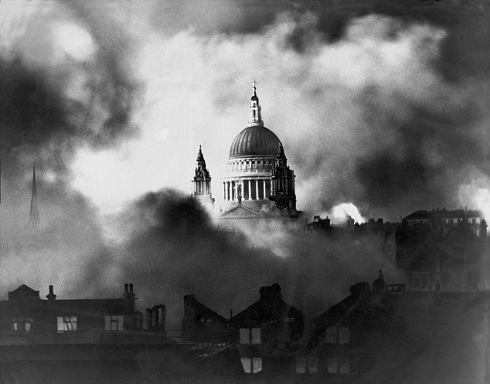

St Paul’s remains standing as a beacon of hope.

Queen’s Concert Hall in Langham Place was also badly hit: a bomb set the roof on fire causing debris to fall into the main hall setting the seats on fire. Just a few hours earlier, the Hall had held 2,400 people listening in rapture to the London Philharmonic Orchestra.

Despite the worst attack so far, Londoners have been working together to clean the city this morning and keep people’s spirits up. Old and young are pulling together to contribute to the war effort. As the smoke parted, St Paul’s cathedral, stood unharmed as a beacon of hope for our city.

Saturday 10th May, 1941

