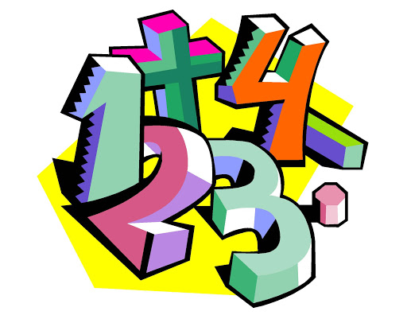

Arithmetic- week commencing 30th March 2020.
Quick recall questions:
- 3/6 X 4/9=
- 2/3 ÷ 4 =
- 132 X 24=
- _______ X 32.33= 32330
- 2/3 + 1 4/5=
Times tables practice! (8 times table):
7 x 8 =
4 x 8 =
60 x 8 =
8 squared?
9 x 8 =
3 x 8 =
6 x 8 =
3 x 8 =
5 x 8 =
11 x 8 =

Percentages of a number:
- 32% of 4400=
- 23% of 1200=
- 95% of 3200=
- 75% of 680=
- 20% of 320=
- 45% of 2600=
- 50% of 4500=

