An extract from My Awesome Japan Adventure by Rebecca Otowa:
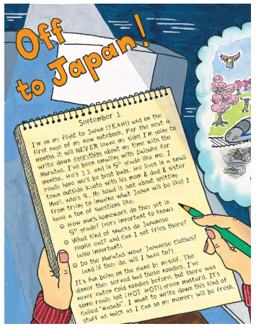
September 1
I’m on my first flight to Japan (YEAH!) and on the first page of my new notebook. For the next 4 months it will NEVER leave my side! I’m going to write down everything about my time with the Muratas. I’ve been emailing Daisuke for months. He’s 11 and in 5th grade like me. I really hope we’ll be best buds. He lives in a small town outside Kyoto with his mum, dad and sister, Mari, who’s 9. My head is just about splitting from trying to imagine what Japan will be like. I have a ton of questions like:
- How much homework do they get in 5th grade? (very important to know)
- What kind of snacks do Japanese people eat? And can I get fries there? (also important)
- Do the Muratas wear Japanese clothes (and if they do will I have to?)
It’s fun being on the plane by myself. The dinner they served had these noodles. I’ve never eaten cold noodles before, but there was some really hot (HOT HOT!) green mustard. It’s called ‘wasabi’. I want to write down this kind of stuff as quick as I can so my memory will be fresh.

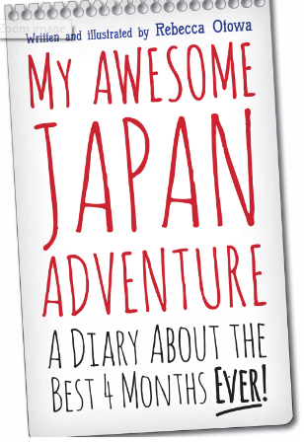
Possible Activities:
- Draw illustrations to go with the extract above. Can you turn the child’s description of the plane journey into a cartoon strip?
- The book doesn’t have any pictures on the front cover. Can you design a new front cover with suitable illustrations?
- Imagine you are on a plane going to Japan. Write a diary about how you feel and what you want to do and find out when
you get there.
- Make a ‘I know, I think, I want to find out’ chart about Japan.
- Write a list of questions that you want to find out about Japan.

