**‘ck’ or ‘sh’ sounds made by the letters ch**

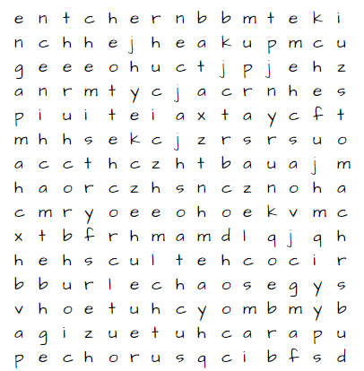

There are 20 words that use the letters ‘ch’ to make a ck or sh sound in the grid

How many can you find?

Can you sort them into ck sounds and sh sounds?