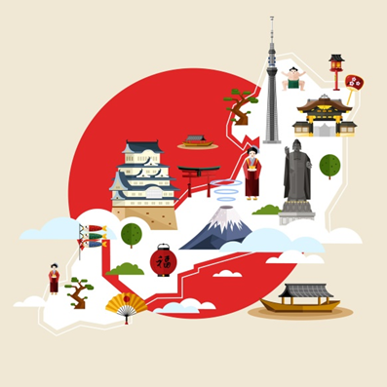

Japan Activities- Culture and traditions.
I have suggested some activities below which are suitable for a Year 5/6 class but can also be done by younger children with some help.
Choose the activities you would most like to do and present them creatively! You can present your work however you like, for example, in the form of artwork, a scrapbook, a PowerPoint.
Our weekly focus for this week is: Culture and tradition.
Suggested activities for the week:
- Learn some numbers/ greetings in Japanese? There are some great videos on YouTube for this and the free language learning app Duolingo has a course in Japanese (this app is excellent!)
- Research some origami patterns and try folding some. You may want to research the story of Sadako Sasaki and the thousand cranes. This is especially relevant as it is all about peace and this week is VE day which is where the whole country celebrated the end of the war. Warning: this story is quite sad.
- Research the traditional sports of Japan including Sumo, Judo and Karate. Do not try these out on your family members!
- Research Samurai warriors.
- Try some Japanese food. You could try out some Sushi rolling at home!
- Research the main religions in Japan- Buddhism and Shinto.
- Research the clothing in Japan and design your own Samurai armour or kimono.
- In England we have the monarchy and government. Is this the same as Japan? Do they have any laws which are different?
- Is there anyone who is famous who was born in Japan?

