Maths week commencing 18th May 2020.
This week we are going to change the Maths slightly and give a list of activities, similar to the afternoon topic work, so you can choose each day, a Maths activity linked to our topic which is suitable. Some days you may want to do a shorter activity, some days you may want to try something longer or slightly more challenging. This week’s topic of focus in Maths is position and direction. At this stage, the children should have a secure knowledge of using the 8 different compass points to describe direction and be able to use co-ordinates over four quadrants (co-ordinates including negative numbers) to describe the position of a point. The children should also be able to describe turns from a position using their angle knowledge applying their knowledge of a full turn (360⁰), a half turn or straight line angle (180⁰) and a quarter turn as a right angle or (90⁰). The children should also be able to use their knowledge of co-ordinates and turns to describe and plot shapes when they have been translated in a direction given, reflect shapes and plot the new position of a shape when it has been rotated. Within year 5 and 6, we also use our knowledge of angles and other shape properties such as number of edges and parallel lines to identify a shape. Below, I have listed a number of different activities that you can choose from to have a go at which focus on position and direction. Some you can download and print a sheet or activity for, others are more practical, so there is a range to choose from to suit what is best for you.
Activities:
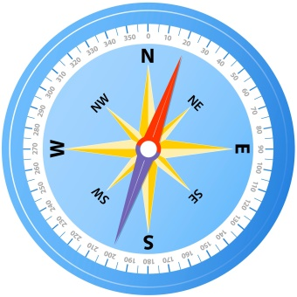
Can you create your own 8 point compass? Think about where you live, can you describe the direction of other places close to you using compass points? For example the local shop is in a North Easterly direction from my house.

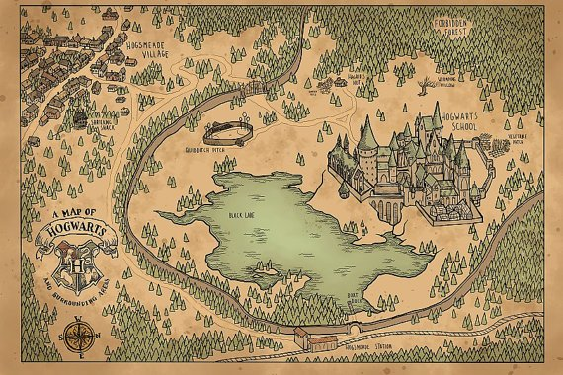
Can you draw a map related to a story you have a read? Or draw a treasure map and then use your 8 point compass directions and knowledge of angles for turns to direct someone to a point on your map. Could you write a list of instructions and see if another person can follow your instructions and reach the place you had chosen? If you prefer not to draw your own map, there are plenty to download from your favourite stories online, I have attached one for Hogwarts!
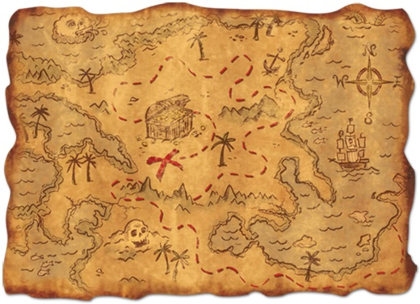
Could you draw your own map? Could be of your local area, a theme park, from a story setting or a treasure island! Can you draw on a co-ordinate grid to your map too? Can you write down the co-ordinates of the main points of the map? At what co-ordinate could you find the shipwreck for example? Or the forbidden tower?
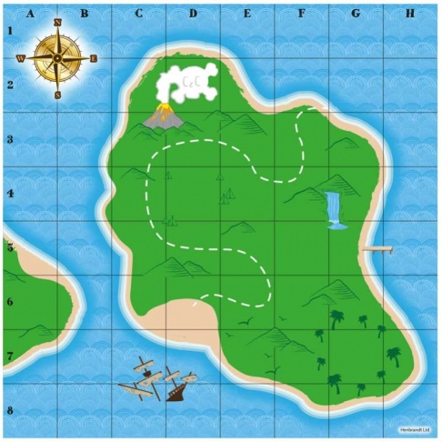

Can you have a go at co-ordinate battleships? Can you guess the co-ordinates of someone else’s ships before they guess yours? I have uploaded a template the class webpage for this if you would like to use it.

On the class webpage, I have attached some challenge cards on plotting co-ordinates in the four quadrants to create shapes- can you challenge yourself?
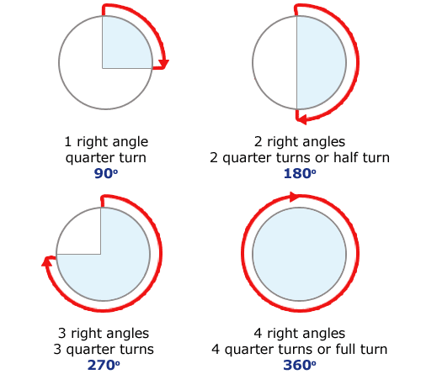
Can you create an obstacle course in the garden and blindfold a member of your family? Can you direct them around the course using directional turns, how far would you need them to turn? Clockwise or anticlockwise?
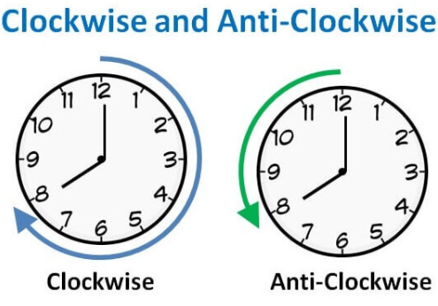

I have uploaded an activity to the class webpage, which with use knowledge of plotting co-ordinates will help you in drawing a picture which will be revealed! Can you plot all the co-ordinates to reveal the picture?
Using chalk or materials you can find outside can you create your own four quadrant grid? Could you put items on your four quadrant grid and write down their co-ordinate? You could even create a large one using paper indoors if you’re feeling creative!
A translation of a shape tells you how far left or right and up or down the shape has moved. You will be able to tell this by focussing on one of the corners of the shape and counting how far the corner has moved left and right or up and down. Can you have a go at translating the shapes? Can you describe the translated shapes? See the activity sheets attached to the website. 1 star at the bottom of the sheet indicates a bronze challenge, two stars is a silver challenge and 3 stars is a gold challenge- the answers are at the end for you to check back!
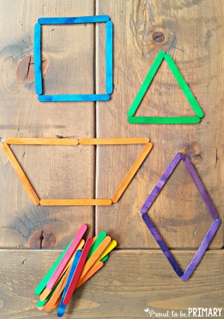
A reflection of a shape is when the shape is reflected over the axis, as if it were a mirror line. Using the bronze, silver and gold challenge activity sheets attached to the class webpage, can you have a go at reflecting some shapes over the axis? Remember, the x axis is the horizontal line and the y axis is the vertical line.
Using what you have around the house, can you create some shapes This could be wool, string, paper, lollipop sticks. Can you write down its properties? Does it have any parallel lines? What angles does it have? Challenge: Is it a regular or irregular polygon?

Can you draw a shape on a post- it note and stick it to another member of your family’s head? Can you describe the shape to them using its properties to help them to guess it?
I have attached some links below if you are stuck with understanding anything above:
https://www.bbc.co.uk/bitesize/topics/zdbc87h/articles/zvvmtv4- Plotting co-ordinates.
https://www.bbc.co.uk/bitesize/topics/z2dqrwx/articles/zcjs97h- Information on how a shape can be transformed. What is translation, reflection and rotation?
https://www.youtube.com/watch?v=25nCv3Cw2n8- A tutorial on how to reflect a shape over a mirror line.
https://www.youtube.com/watch?v=8Dtz5fBe7_Q- How to translate a shape.

