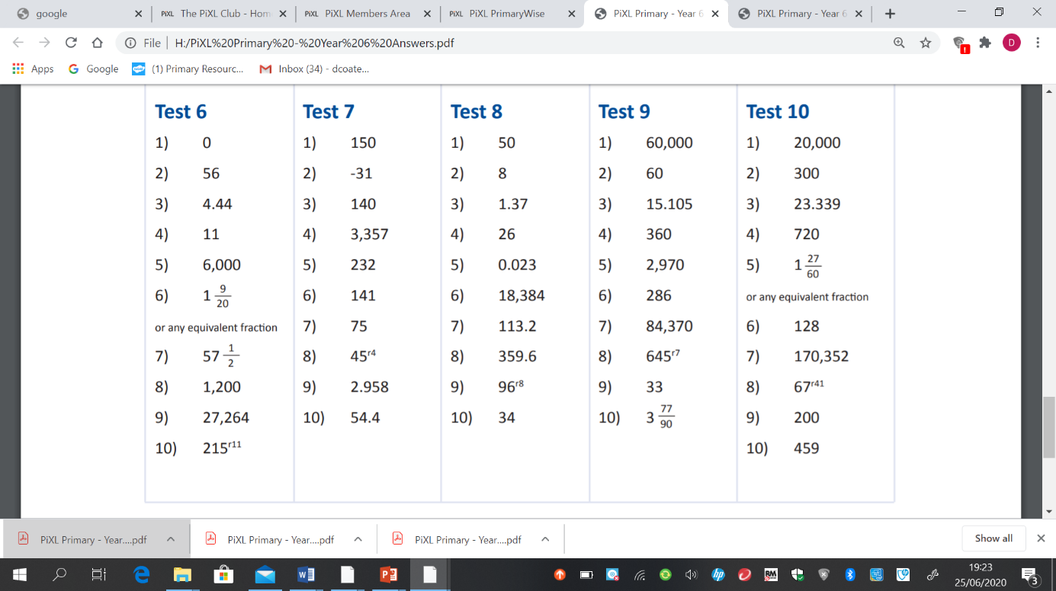**Arithmetic test 7 answers.**