If a jumper usually costs £20, how much will it cost in a half-price sale?
I bought my new toaster in John Lewis’s half-price sale. It cost me £12. How much would it have cost before the sale?

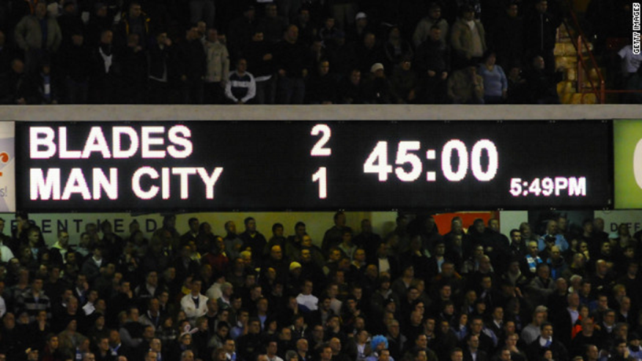
A football match is 90 minutes long.
What does 45:00 mean on this scoreboard?
If a match begins at 3:00pm, what time will half time be? (Assume there is no added time.)

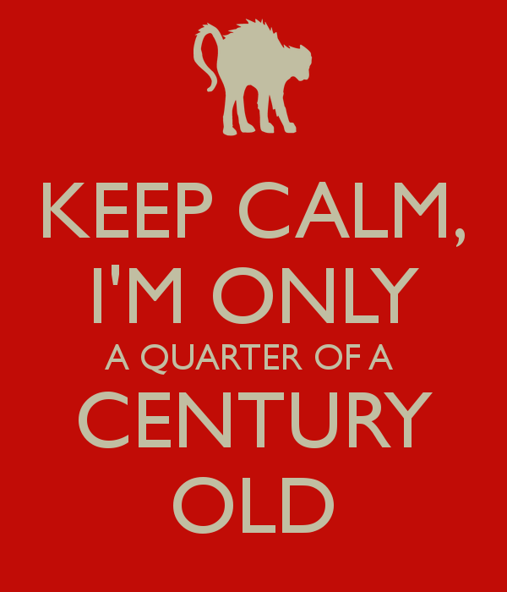
1 century is 100 years.
Mr Calow is a quarter of a century old. How old is he?
Mrs Groves is half a century old. How old is she?

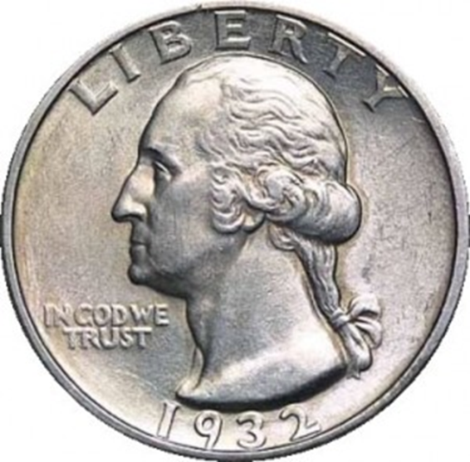
1 quarter dollar is worth 25 cents.
2 quarter dollars are worth _______ cents.
3 quarter dollars are worth _______ cents.
4 quarter dollars are worth ________ cents.

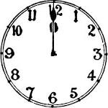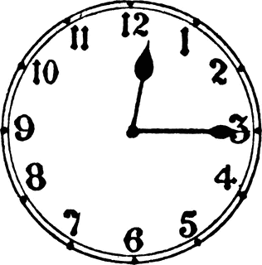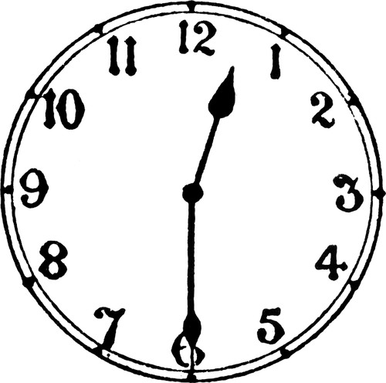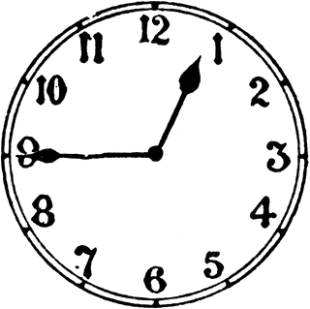
12 o’clock quarter past 12 half past 12 quarter to 1

What does the quarter relate to in ‘quarter past 12’?
What does the half relate to in ‘half past 12’?
What does the quarter relate to in ‘quarter to 1?

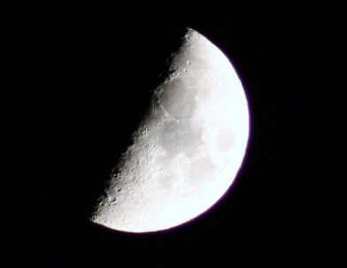
Why is this called a half-moon?
What would a full-moon look like?

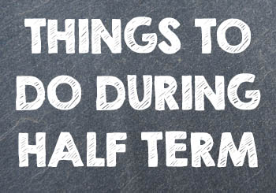
The autumn term began at the end of August. Half term was in October. The autumn term ends in December.

Why do you think half-term is called half-term?

