I have chosen 2 pairs of glasses. I’ll have to pay full price for my first pair, but my second pair has got a 1/3 discount.
Both pairs are £210 at full price.
How much will the 2nd pair cost?
How much will I pay altogether?

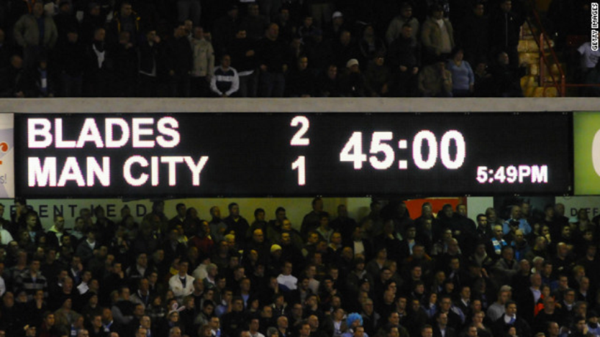
A football match is 90 minutes long.
What does 45:00 mean on this scoreboard?
If a match begins at 3:30pm, what time will half time be? (Assume there is no added time.)
If there is no added time played, and half-time lasts for 15 minutes, what time will the full-time whistle blow?

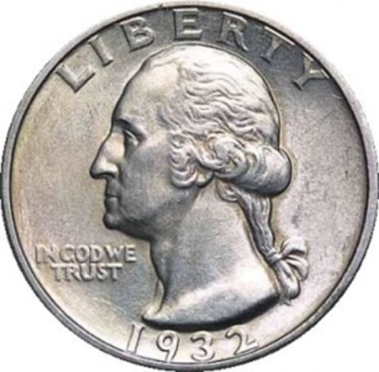
There are 100 cents in a US dollar: $1=100 cents
How many cents is a quarter dollar worth?
How many quarter dollars would you need if you wanted to buy a book for 6 dollars?
Polly has saved up 37 quarter dollars in her piggy bank. How much is this in dollars and cents?

take-off
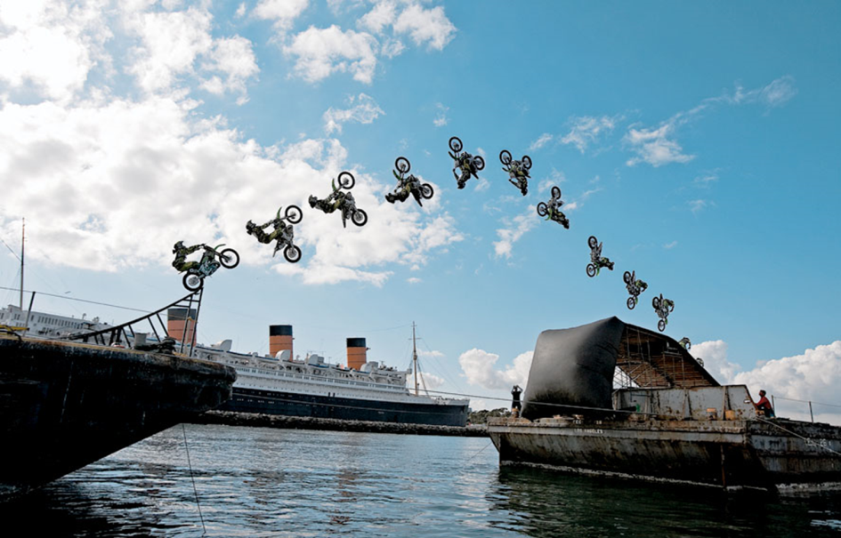
If the camera takes a photo every ¼ of a second, how long is it from when the bike leaves the ramp to when it lands on the other side of the river?
landing

How long does it take for the bike to complete a half-turn in the air?

If a settee usually costs £868, how much will it cost in a half-price sale?
I bought my new toaster in John Lewis’s half-price sale. It cost me £36. How much would it have cost before the sale?
A bike is in a sale with a third off. Its original price is £360. What is its sale price?

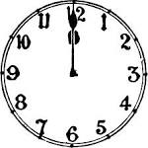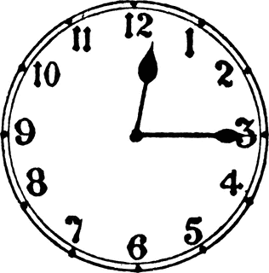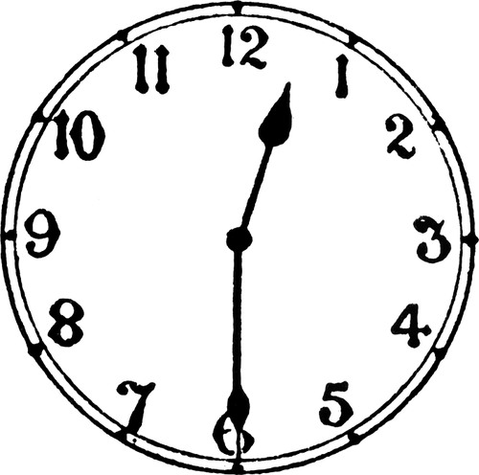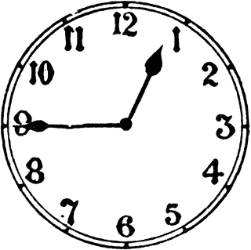
12 o’clock quarter past 12 half past 12 quarter to 1
What does the quarter relate to in ‘quarter past 12’?
What does the half relate to in ‘half past 12’?
What does the quarter relate to in ‘quarter to 1?
How many ‘half-hours’ are there in a whole week?

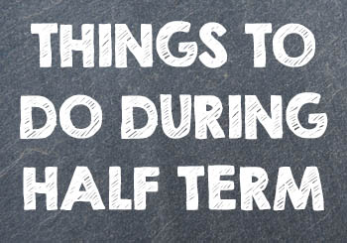
The autumn term began at the end of August. Half term was in
October. The autumn term ends in December.
Why do you think half-term is called half-term?

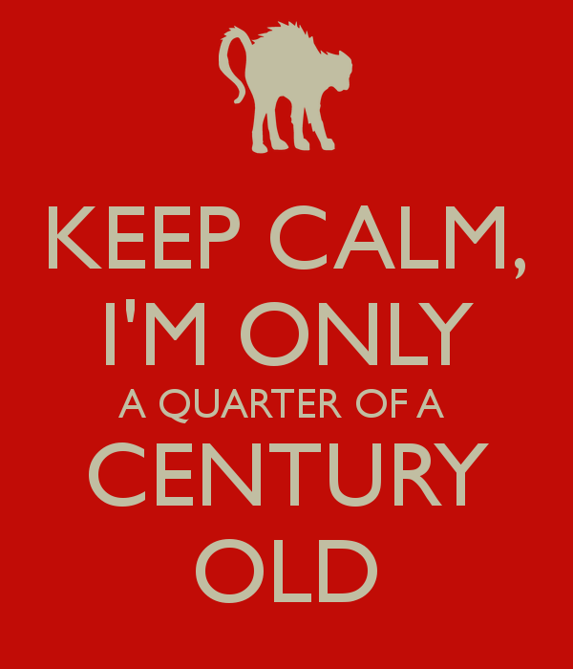
Isabelle is $\frac{1}{50}$of a century old. How old is she?
Alex is $\frac{1}{25}$ century old. How old is she?
Mrs Coverley is $\frac{3}{4}$ of a century old. How old is she?
Mr Dean is $\frac{7}{10}$ of a century old. How old is he?
Miss Totman is $\frac{1}{5}$ of a century old. How old is she?
Helen is $\frac{3}{5}$ of a century old. How old is she?

