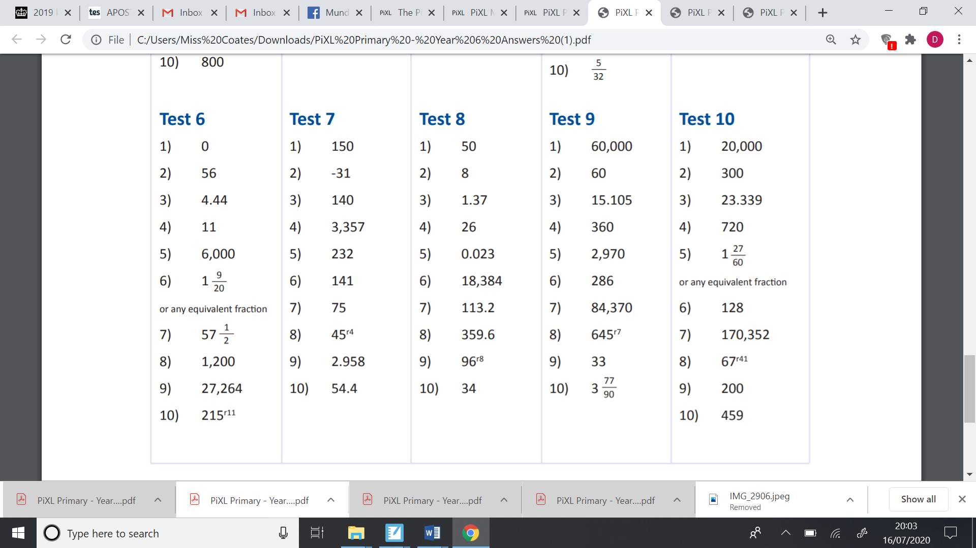**Arithmetic test 10 answers.**