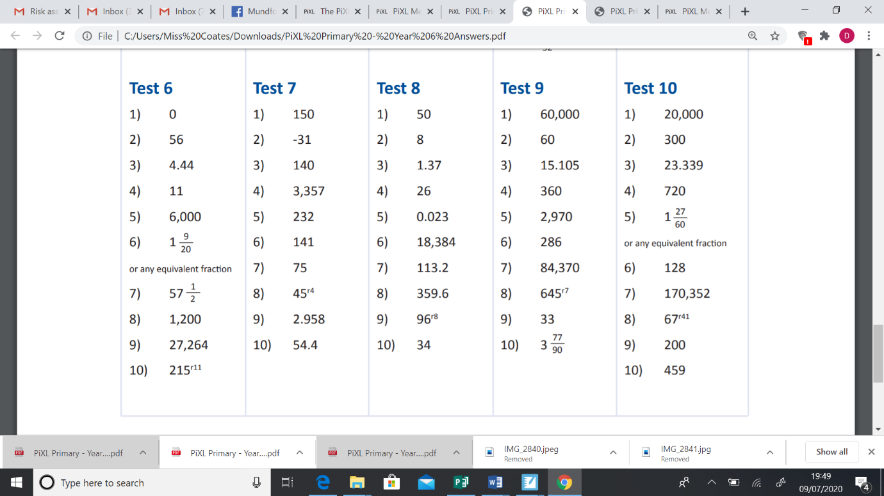**Arithmetic test 9 answers.**