- Convert the following
- 8 days = _________ minutes
- 3 weeks = _________ hours
- Half an hour = ________ seconds
- Write these times in order, starting with the shortest.

24 days, 600 seconds, 48 hours, 1 month, 7 minutes, 660 minutes
- What is 444 minutes in hours and minutes?
- There are 12 weeks until Danny’s birthday.
- How many hours until his birthday?
- How many minutes is that?
- Beth is on holiday at Abersoch. High tide this morning is 7.35 a.m.. The next high tide is in 12 hours 23 minutes time.

- What is the time of the next high tide?
- What is 12 hours 23 minutes, in minutes?
- These clocks show the start and finish times of a TV programme.

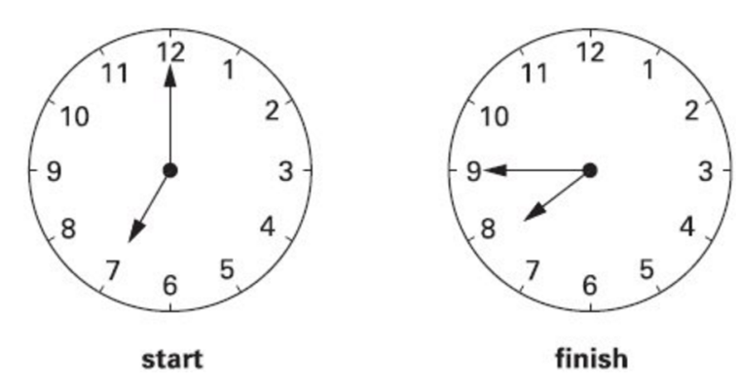
- For how many minutes does the programme last?

- How many seconds is that
- An aeroplane takes off on Tuesday at 22:47 It lands on Wednesday at 07:05

How long in hours and minutes is the flight?

Next steps

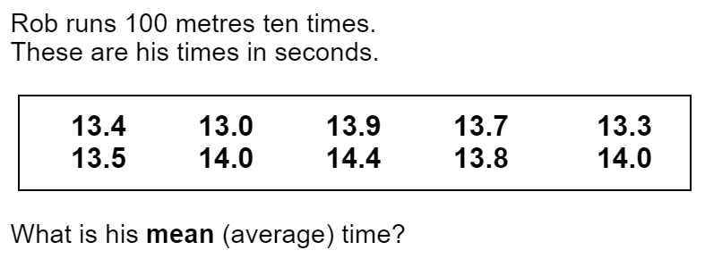

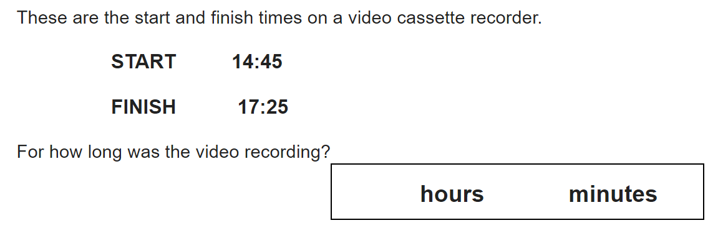

How many Minutes is that in total?
How many seconds is that in total?

