Monday -

This week we will be looking at some problems which require thinking and often have multiple answers. This is what we call algebraic thinking in primary school; we don’t use algebra in more advanced forms until a few years time!
Today I would like you to try a problem which requires trial and error, a lot of thinking, and has multiple answers. If you already did the first problem (we looked at this in class prior to the school closures and something similar in home learning) , then please try the second problem (the ark problem). If you didn’t do the first problem, or struggled with it before, feel free to do this one again.

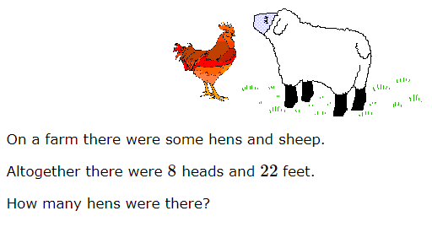

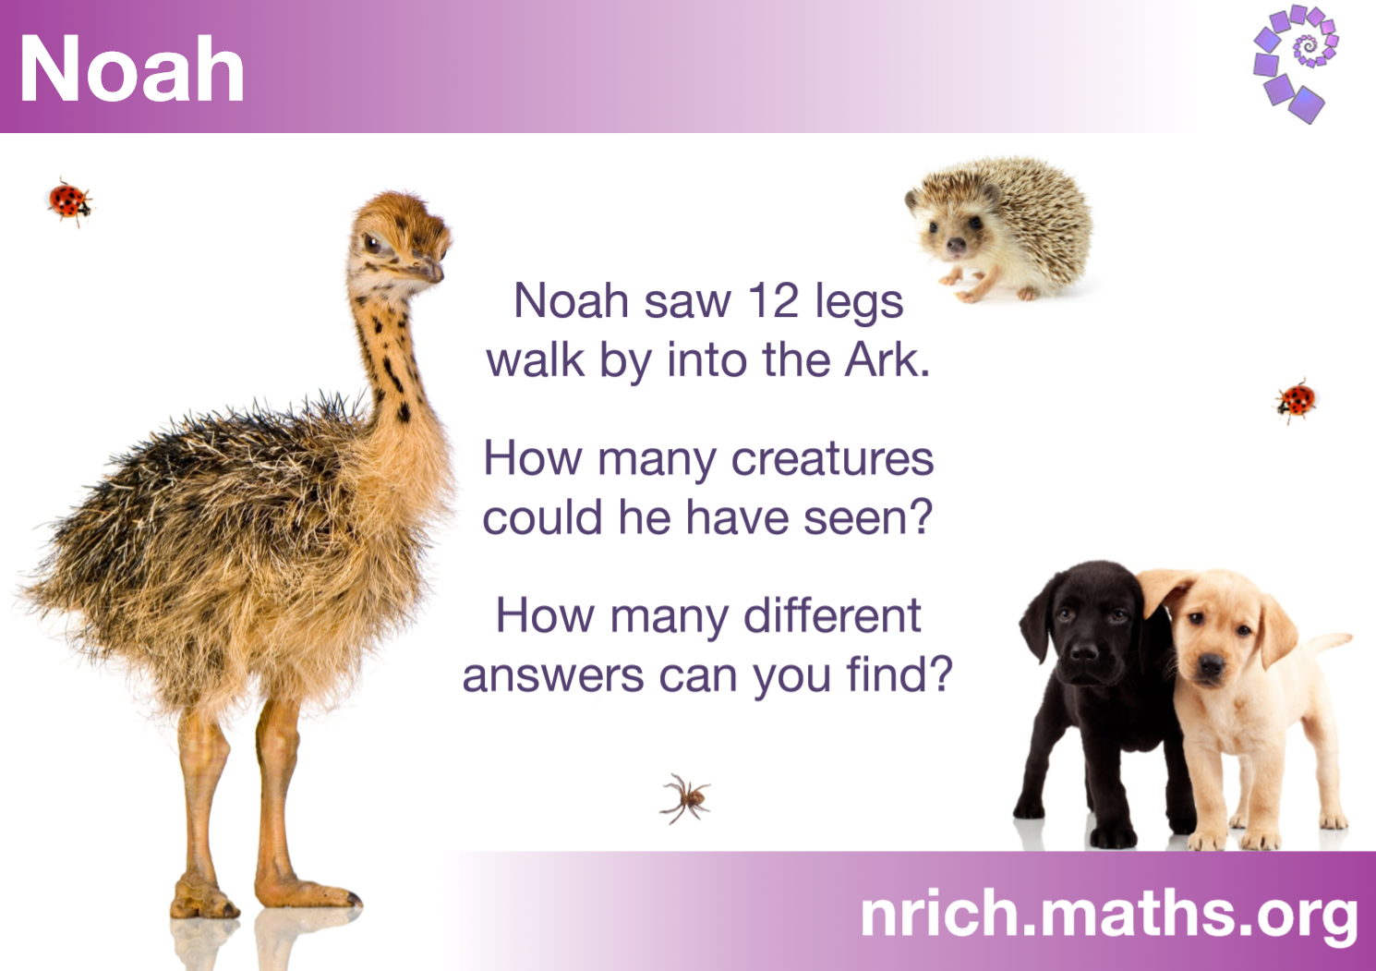

Tuesday -

Today I would like you to work on some missing number problems. Fill in the blanks to complete the problems! You can either count on to help you get the answer, or invert the problem.

Let’s look at question 1 as an example: 3 plus something equals 20.
I could do this in two ways:
1) Count up from 3 to 20 and see how many more 20 is than 3.
2) Invert the problem to 20 – 3 = ? This way I can carry out a simple subtraction and still get the same answer!
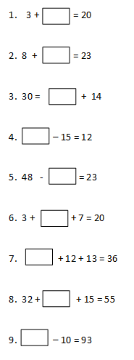

Wednesday -

I was exploring a puzzle in which headless match sticks had to be moved to make a different number of triangles.
I made one small triangle
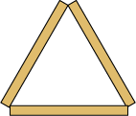 | 3 matches
I made it into 4 small triangles by adding 6 matches.
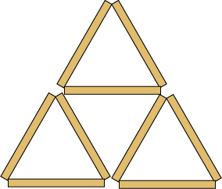 | 9 matches
I added another row and counted the number of small triangles and counted the matches.
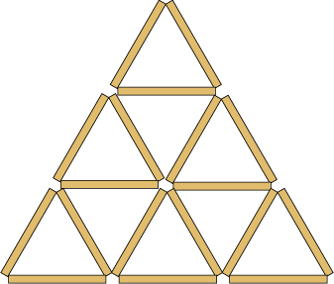

I made a table of my results and continued adding rows. I found many patterns.
Have a go and see what patterns you can find. You do not have to use match sticks (or cocktail sticks) - drawing lines will do just as well.
Find a good way to record your results. See if you can predict the numbers for rows of triangles you have not drawn.
When you have done all you can with triangles, see if you get the same sort of results with squares. Then think of other shapes which might make number patterns as they grow.

Thursday -

Today I would like you to work on some missing number problems, but these ones are on multiplication and division. Fill in the blanks to complete the problems! Use your times table facts and related division facts to help you (this was our arithmetic focus a few weeks ago).

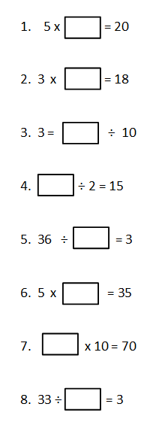

Friday -

Today I would like you to finish off your week by solving the following problems. I have removed the operation (add, subtract, multiply, divide) in the following questions. Find and insert the correct operation to complete each question.

